Changed Selenium – Playwright prompts using “Vibe coding” in Visual Studio
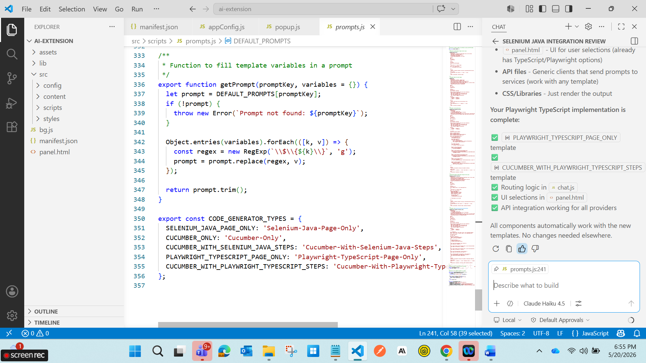

Extension removed and reloaded.
Changed the settings as “Playwright” and others accordingly.
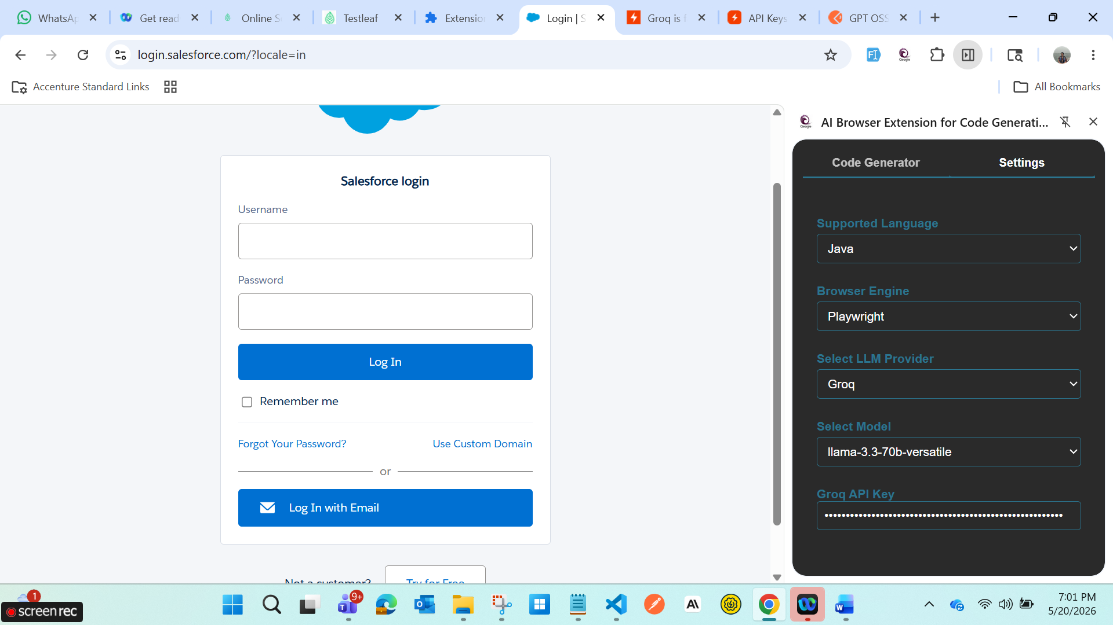
Test cases created.
